
A vehicle history report, also known as a vehicle condition report or vehicle inspection report, is a complete
assessment of a used car. The report provides an overview of the car's history. This includes the general body condition, as well as finer details like, whether there are any interior odors (VHR)
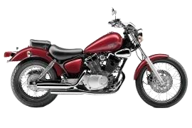

SUZUKI

DR
-
Z

VIN#

JS1BB111107100676

VEHICLE SPECIFICATIONS:

Make: Suzuki
Model: DR-Z 400SM
Year: 2019 Oil Capacity: 2.5 L
Power: 30 kW @ 9,000 rpm / 42.7 Nm @ 7,000 rpm

Displacement: 398.0 cc
Engine: Liquid-Cooled, Single-Cylinder, Four-Stroke Engine
Transmission: 5-Speed Constant Mesh
Fuel: Petrol / Gasoline

Tank Size: 3.2 gallon Overall Length: 2200 mm
BORE X STROKE: 90.0 mm × 62.6 mm (3.54 in × 2.46 in)
Brakes: Disc with a 2-piston caliper / single-piston caliper

Overall Height: 1256 mm Overall Width: 820 mm
City Fuel Mileage: 40 to 45 MPG (miles per gallon)
Highway Fuel Mileage: 50 to 55 MPG (miles per gallon)
Suspension: Inverted telescopic fork 47 mm/ Link-type shock absorbers
Tires: Front- 120/70-17/ Rear- 140/70-17

Turning Radius: 3.3 m

VEHICLE HISTORY AT A GLANCE:



Auction Brand / Issues

Not Found

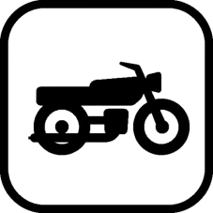

Accident / Damage

Not Found



Insurance Loss / Transfer

Not Found



Certified Pre
-
Owned

Not CPO Found

Service / Repair

Not Found



Additional History

Events Reported

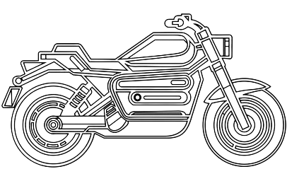
ACCIDENT & DAMAGE:

Not all accidents and/or damage events are reported
(
NO RECORDS FOUND
)
.

Airbag Deployed

Structural Damage

Overturned

Severe

THEFT RECORDS:

Vehicle Stolen Summary No Records Found

TITLE BRAND INFORMATION:

No Brands Reported

BRAND CATEGORY STATUS
Clear No Records Found
Flood Damage No Records Found
Fire Damage No Records Found
Hail damage No Records Found
Salt Water Damage No Records Found
Vandalism No Records Found
Kit No Records Found
Dismantled No Records Found
Junk No Records Found
Rebuilt No Records Found
Reconstructed No Records Found
Salvage No Records Found
Test Vehicle No Records Found

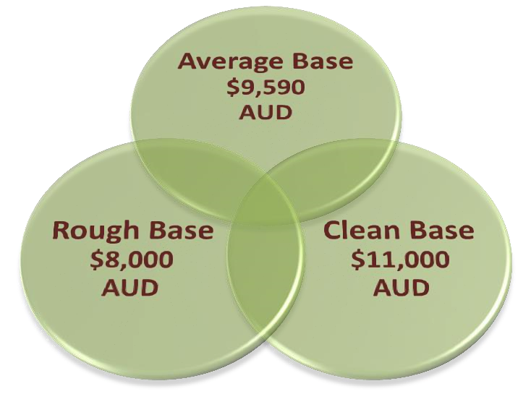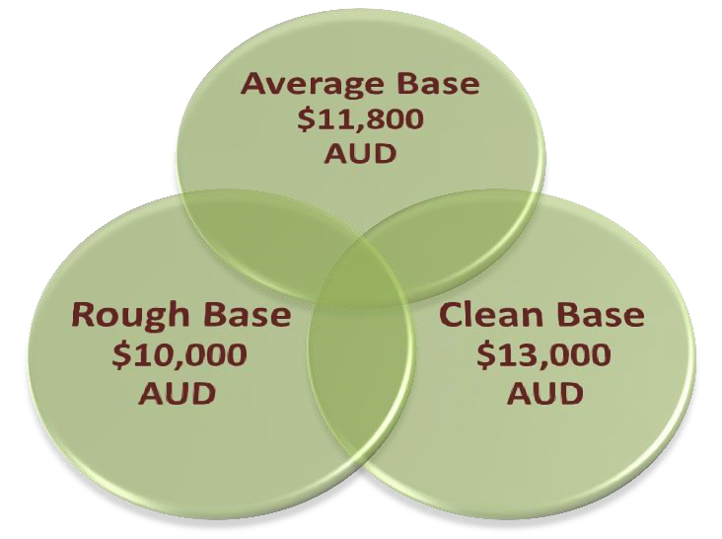
BLACK BOOK VALUE
INFORMATION:

Trade
-
In Values

Retail Values

VEHICLE GOODS & BADS:

GOODS:
- Versatile Performance: It's capable on both city streets and light off-road trails, making it a great all-rounder.
- Lightweight: The bike’s relatively low weight enhances agility and makes it easy to handle.
- Powerful Engine: The 398 cc single-cylinder engine delivers good torque and power for its class.
- Adjustable Suspension: The suspension is adjustable, allowing riders to customize settings for comfort and performance.
- Reliable Build: Suzuki is known for its durability, and the DR-Z400SM is built to last with minimal maintenance.
- Comfortable Seating Position: The upright seating position is comfortable for longer rides and city commuting.
- Good Fuel Efficiency: Offers respectable fuel economy, making it cost-effective for daily use.
- Aftermarket Support: A wide range of aftermarket parts and accessories are available for customization and upgrades.

BADS
- Limited Wind Protection: The bike has minimal fairing, which can result in wind fatigue during longer highway rides.
- Vibration at Higher Speeds: The single-cylinder engine can produce noticeable vibrations at higher RPMs, which may affect comfort on longer journeys.
- Suspension Travel: While great for light off-road use, the suspension might not handle more aggressive off-road riding as well as some dedicated dirt bikes.
- Seat Comfort: The seat can be firm for extended rides, which may require additional cushioning for long distances.
- Limited Power for Highway Riding: While adequate for city use, some riders might find the power lacking for sustained high-speed highway cruising compared to larger displacement bikes.

Performance Rating:

4.7/5

Drive Rating:

4.8/5

Consumer Rating:

4.7/5

Quality Rating:

4.7/5

Overall Rating:

4.7/5
UNITS SALE AFTER MANUFACTURING:



Sales

1
st Year
2
nd Year
3
rd Year
4
th Year



0
5
10
15
20
25
1
/
1/2019
/
1/2020
1
1
/
1/2021
/
1/2022
1
1
/
1/2023
UPSALE GRAPH

UPSALE GRAPH

DISCLAIMER:

This vehicle history report is provided for informational purposes only and is based on available data at the time of the report. While we strive to ensure the accuracy and completeness of the information presented, we cannot guarantee that it is free from errors or omissions.

The report includes information from various sources, including but not limited to, registration records, title information, and accident reports. However, it is important to note that this report may not encompass every detail or event related to the vehicle's history. It is advisable for prospective buyers to perform their own due diligence, including obtaining a professional vehicle inspection and verifying details with relevant authorities or service providers.

This report does not constitute an endorsement or guarantee of the vehicle’s condition, reliability, or value. The seller or dealer may have additional information about the vehicle that is not reflected in this report.

By using this report, you acknowledge that we are not liable for any inaccuracies or losses arising from reliance on the information provided.

For the most current and comprehensive vehicle history, we recommend contacting official sources or professional services.

IMPORTANT:

If you intend to purchase a vehicle from a private seller, you are strongly advised to visit the verveteck verifications to ensure that the vehicle is not encumbered. To do this goes to verveverifications.com

MORE ABOUT:

Certainly! Here’s a description highlighting the imp. of the 2019 Suzuki DR-Z400SM.

2019 Suzuki DR-Z400SM: A Definition of Reliability and Capability.

Capability
The 2019 Suzuki DR-Z400SM is known for its versatility, making it capable in various riding scenarios:
- On-Road Performance: The bike handles city commuting and highway cruising well, offering a responsive throttle and decent top speed for its class.
- Light Off-Roading: With its long suspension travel and dual-sport tires, it can tackle light trails, gravel roads, and some rough terrain effectively.
- Agility: Its lightweight design contributes to nimble handling, allowing riders to navigate through traffic and tight corners with ease.
- Customizability: The bike's design allows for a wide range of aftermarket parts, enabling riders to tailor it to their specific riding preferences, whether for street or off-road performance.

Reliability
Suzuki has a reputation for building durable and reliable motorcycles, and the DR-Z400SM is no exception:
- Proven Engine: The 398 cc single-cylinder engine is known for its longevity and ease of maintenance, with many owners reporting high mileage without significant issues.
- Low Maintenance: The bike’s simple mechanical design and accessible components make routine maintenance straightforward, contributing to its overall reliability.
- Durability: The build quality and materials used in the DR-Z400SM stand up well to wear and tear, whether on the road or light trails.
- Resale Value: Suzuki motorcycles generally retain their value well, and the DRZ400SM is no different, making it a sound investment for riders.
5.
Overall, the combination of capability and reliability makes the 2019 Suzuki DR-Z400SM a popular choice among both new and experienced riders looking for a versatile motorcycle.

